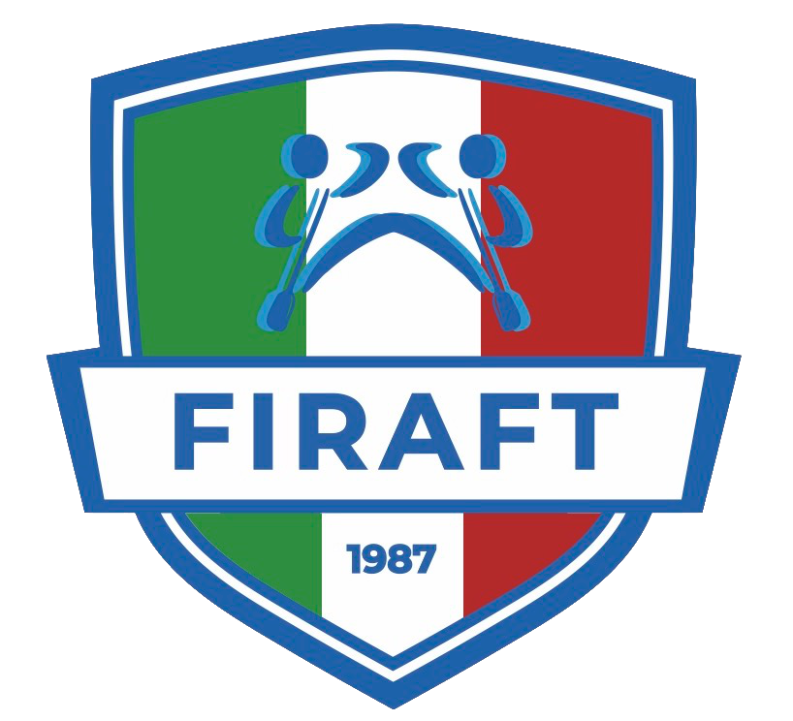
FIRAFT Membership Disclaimer

Membership application (for over 18 years old)
The undersigned demands to be registered for Federazione Italiana Rafting as “amateur-tourist”, by means of one of our affiliates.

The undersigned, by submitting this form, declares:

- to have not experienced any pathology that could represent a contraindication for the activity for which he/she is demanding the membership;
- to expressly accept all the rules of the Statute and the F.I.Raft and C.O.N.I. Regulations and to observe and fulfill them without exception;
- to give consent to the processing of personal data in accordance with the art.13 of GDPR and having read the information below regarding the methods and purposes described at point 1a, closely related and instrumental to the management of the membership relation, that allow for their treatment, to the extent necessary to the performance of the statutory purposes;
- to authorize the organization affiliated to F.I.Raft to use the images and/or to make videos that include him/her. He/she also declares that the associate owns him/her nothing for the using this material, either now or in the future, that could be used for brochures, website, posters, stickers, calendars, holding from responsibilities whoever will use the material.

Considering the above and sending this form I agree with what stated in the previous points, from 1 to 4, in accordance with the art.1341 et seq. of the Italian Civil Code.

Additional clause for guardians or parents of minors
The undersigned, as person with parental responsibility or legal guardian, by submitting this form, declares:
- To accept for and on behalf of the minor what stated in the membership application and/or in the activity consent form above;
- to give consent to the processing of personal data in accordance with the art.13 of GDPR and having read the information below regarding the methods and purposes described at point 1.

Considering the above and sending this form I agree with what stated in the previous points, from 1 to 2, in accordance with the art.1341 et seq. of the c.c.

INFORMATION ON THE PROCESSING OF PERSONAL DATA

ART. 13 OF EU REGULATION 679/2016

(GENERAL DATA PROTECTION REGULATION - GDPR)

Dear User,
Conforming to art.13 of EU Regulation 679/2016 (hence “GDPR”) we inform you that your personal data, that you provided, will be processed by Federazione Italiana Rafting (abbreviated as “F.I.Raft” or “Federation”) acting as data controller (hereinafter “Data Controller”), and could be subject to processing in the manner described by this Privacy Policy and in accordance with the confidentiality principle that guides the activity of the Federation.

- LEGAL BASIS AND PURPOSE OF THE PROCESSING
The legal basis of the processing (by way of example) is based on the permission of personal data processing, Legislative Decree n. 242/1999 and subsequent amendments and integration, on the existing rules on suitability for the sports practice Ministerial Decree on 18/02/1982 and Ministerial Decree on 24/04/2013) and on the CONI statute.
The personal data of the undersigned and those for whom he/she books, acquired at the time of the booking, will be processed for institutional purposes, for example:
- implementation of the booking activities;
- implementation of the activities related to the relationship established over the booking process, including the activities related to the management of relations with insurance companies;
- requirements connected and obligations under the law, regulations, statute and federal regulations and, in general, national and international regulations, from time to time in force.

- METHOD OF TREATMENT
The data will be processed in the following way: on manual spreadsheets, made with the help of electronic means, stored in enclosed places with reserved and selected access, with a computerized system providing support against cyber risks (firewall, antivirus, periodic backup of data); the data could be processed by internal or external entities, that are specifically authorized and had undertaken to confidentiality.
See art. 4, paragraph 2, GDPR for the definition of “treatment”.

- PROVISION OF DATA AND REFUSAL
The provision of “ordinary” personal data (for example name, phone number and email address) is strictly necessary for the purpose of performing the activities referred to in point 1a. It may also happen that the provision of specific “sensitive” personal data (for example health data and personal data regarding the state of health, also in relation to necessary treatment about national health emergencies) is necessary for the purpose of performing the activities referred to in point 1. Any refusal of the party concerned to provide personal data makes it impossible to perform the activities referred to in point 1.

- DATA COMMUNICATION
The personal data may also be processed on behalf of the owner, for the purposes referred to in point 1a, by third-party companies that work on behalf of co-owners, in their capacity as external managers of the processing (this includes but is not limited to: lenders, professional offices, suppliers/consultants who manage and/or participate in the management and/or maintenance of the electronic and/or telematic tools that we use, insurance companies for the time strictly necessary to the successful execution of that service, contractors). Your personal data will be made accessible only to those who need it due to their job of hierarchical position. These parties will be properly instructed to avoid data loss, destruction, unauthorized accesses or unauthorized processing of the data. The affiliate will operate as autonomous owner of the processing. Without your express consent, the holder may communicate your data to supervisory bodies, legal authorities as well as to all the parties to which a mandatory release is expressly provided by the law.

- DISCLOSURE OF YOUR DATA
Personal data are not subject to disclosure, without the prior express consent of the data subject.
- TRANSFER OF DATA ABROAD
The personal data can be transferred towards Countries belonging to the European Union and towards third party countries outside the European Union, exclusively under the purposes stated in point 1. In such a case the data controller assures hereby that the transfer of data outside the EU will be done in accordance with the art. 44 et seq. of the Regulation and with applicable legal provisions, stipulating, if necessary, agreements that guarantee an adequate level of protection.

- DATA RETENTION
The data are kept for the time strictly necessary to the performance of the activity referred to in point 1a, in accordance with the civil code, the fiscal legislation and the CONI and WRF rules and regulations, for a period not exceeding 10 years. The verification of the obsolescence of the data stored in relation to the purposes for which they were collected is regularly carried out. There is absolutely no automatic decision-making process or profiling activity, referred to in the art.22, GDPR paragraphs 1 and 4.
- RIGHTS OF THE DATA SUBJECT
As an interested party to the data treatment, we inform you that you have the possibility to exercise the rights required by the Regulation, precisely:

  - The right, in accordance with art.15, to obtain confirmation that there is or there is not an ongoing treatment of personal data concerning you and, if there is, to obtain the access to personal data and the following information: i) purpose of the processing ii) categories of personal data processed iii) recipients or categories of recipients to whom the data have been or will be communicated, especially if third-countries or international organizations iv) personal data retention period, whenever possible, or, if it is not possible, the criteria used to determine that period v) the existence of your right to request from the data controller the rectification or deletion of personal data, or the restriction of the processing of your personal data, or to object to their processing vi) the right to complain at the authorities, in accordance with art.77 et seq. of the Regulation vii) in the event that personal data are not collected from the data subject, all available information regarding their origin; viii) the existence of an automated decision-making process, including the profiling mentioned at art.22 paragraphs 1 and 4 of the Regulation and, in such cases at list, meaningful information about the logic used, as well as the importance and the consequences of this processing concerned for the interested party ix) the right to be informed about the existence of appropriate guarantees in accordance with the art.46 of the Regulation regarding the data transfer, if the personal data are transferred to a third country or an international organization;
  - The person concerned will also have (whenever possible) the possibility to exercise the rights foreseen by the art.16-21 of the Regulation (right of rectification, right to oblivion, right of treatment limitation, right to data portability, right of opposition)

We inform you that the owner commits to answer your requests no later than one month from the date of receipt. The term could be extended depending on the complexity and number of the requests and the data controller will arrange to explain the reasons for prolonging within one month of your request. The outcome of your request will be provided in written or in electronic format.
- DATA CONTROLLER
The data controller is the “Federazione Italiana Rafting” with registered office in Piazza San Paolo, 2, 13900, Biella (BI), C.F./P.I. 00689760148, tel. 0165 51 64 14 - E-mail: segreteria@federrafting.it
The updated list of data processors is available, by sending an Email to segreteria@federrafting.it.

The Data Controller
Federazione Italiana Rafting (F.I.Raft)

